4.Blogging: Create your first blog – 500 – 800 words on wordpress blog ( grammarly ,COPYAI) and promote the blog on any of the social media of your choice not by posting the blog directly but by creating a promo link for the blog and attach a minimum of 50 likes on the blog.

Blog Name: RT-2 AI model

Category: Artificial intelligence technology

Email: [kadhavai5@gmail.com](mailto:kadhavai5@gmail.com)

Wordpress Blog URL: <https://kadhavai5.wordpress.com/>

Social media video post screen shot:

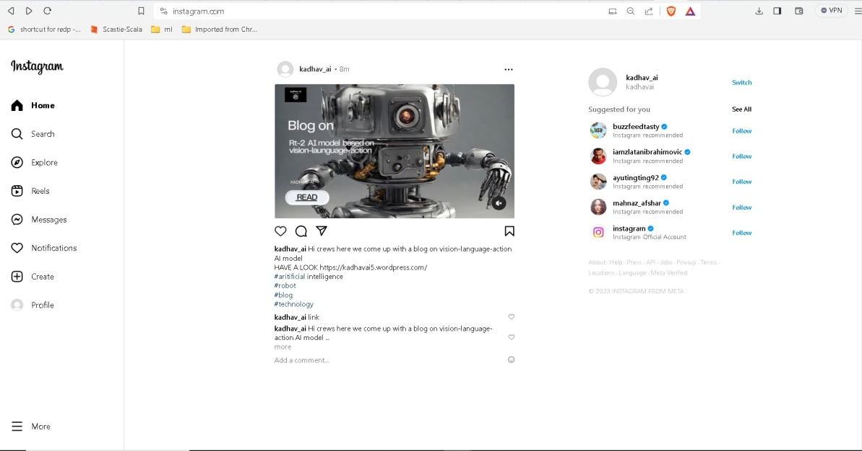

Steps:

1. Creating a wordpress account:

As I have already created the account so I am giving “continue with google”

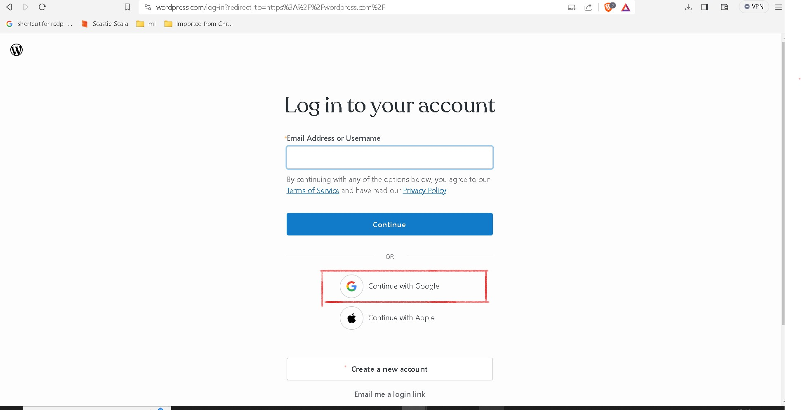

1. Click POST : then click ALL POST : then click ADD NEW POST

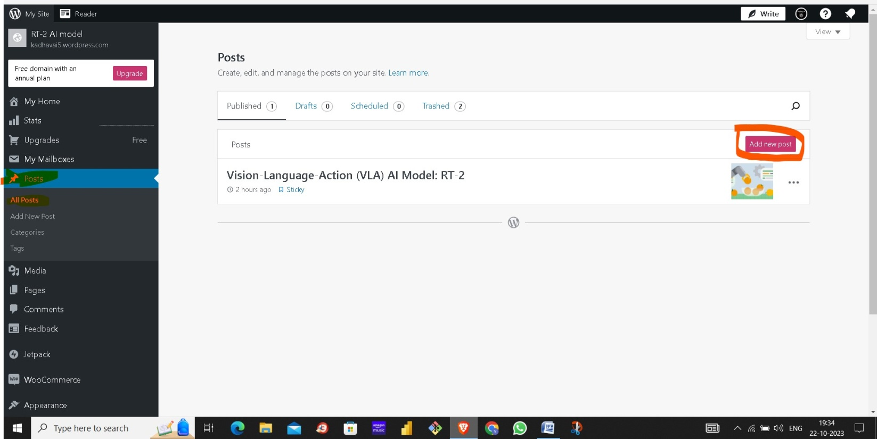

1. Now add title and add content to the post

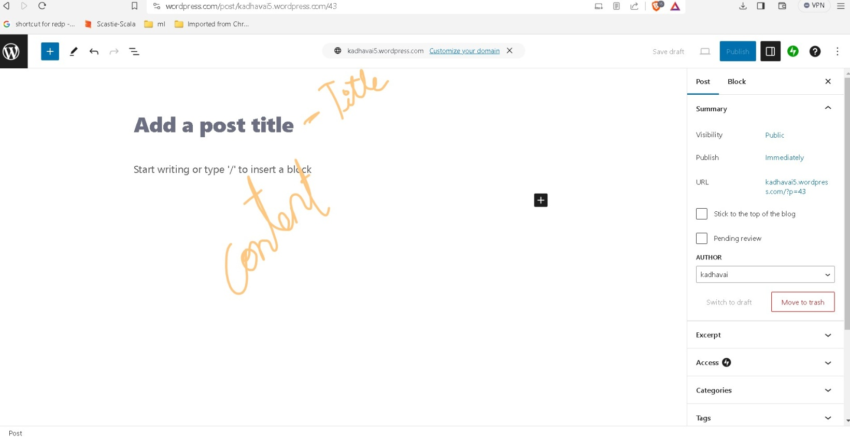

1. Click on PUBLISH

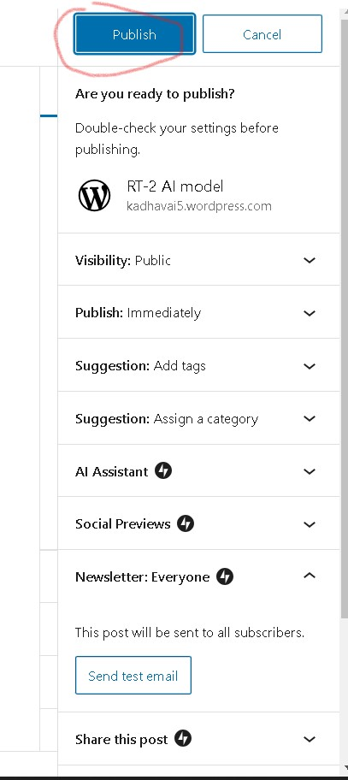

1. Then go to SETTING and Click GENERAL and add SITE TITLE and SITE TAGLINE and click SAVE SETTINGS

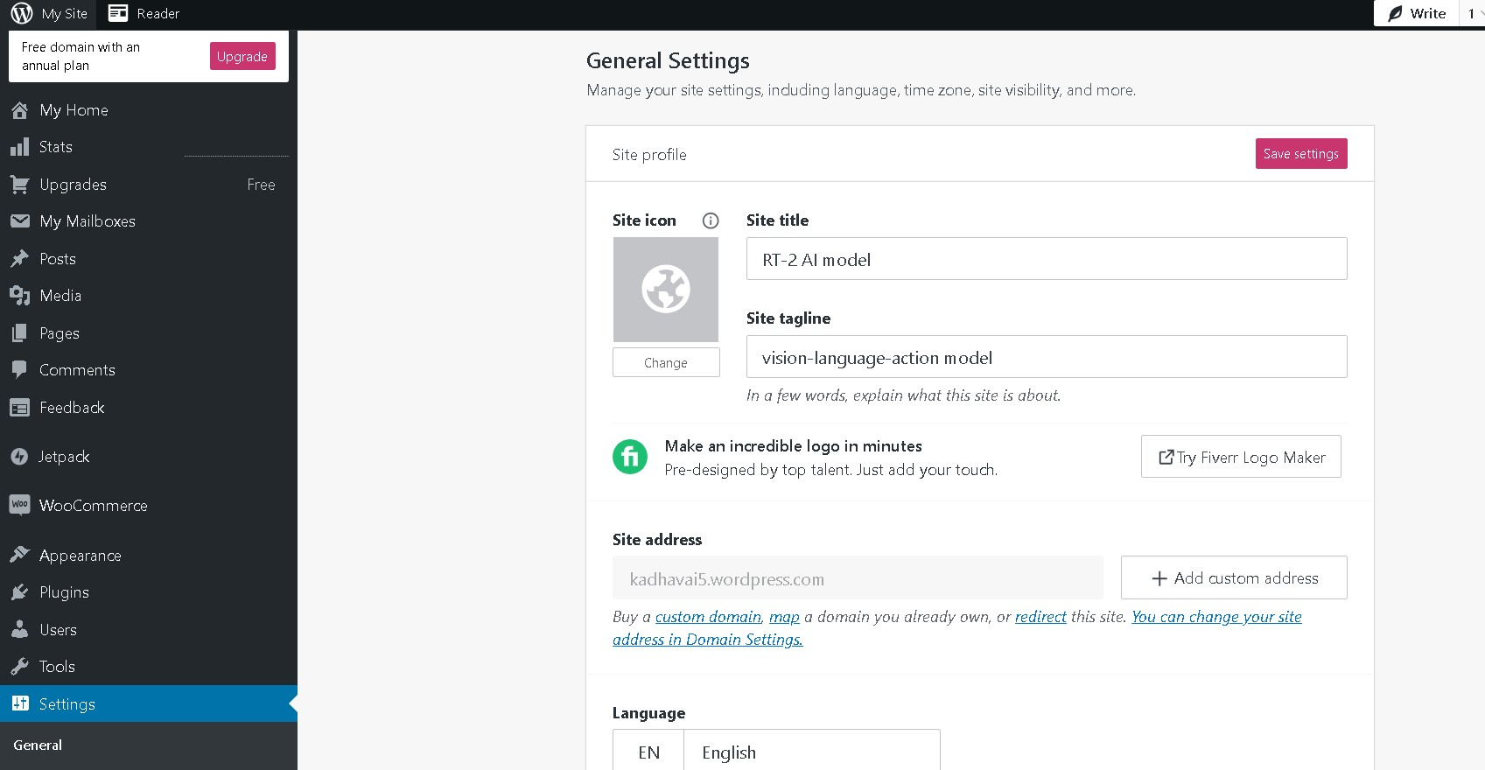

1. Click on PAGES and ADD PAGE and create ABOUT and CONTACT page

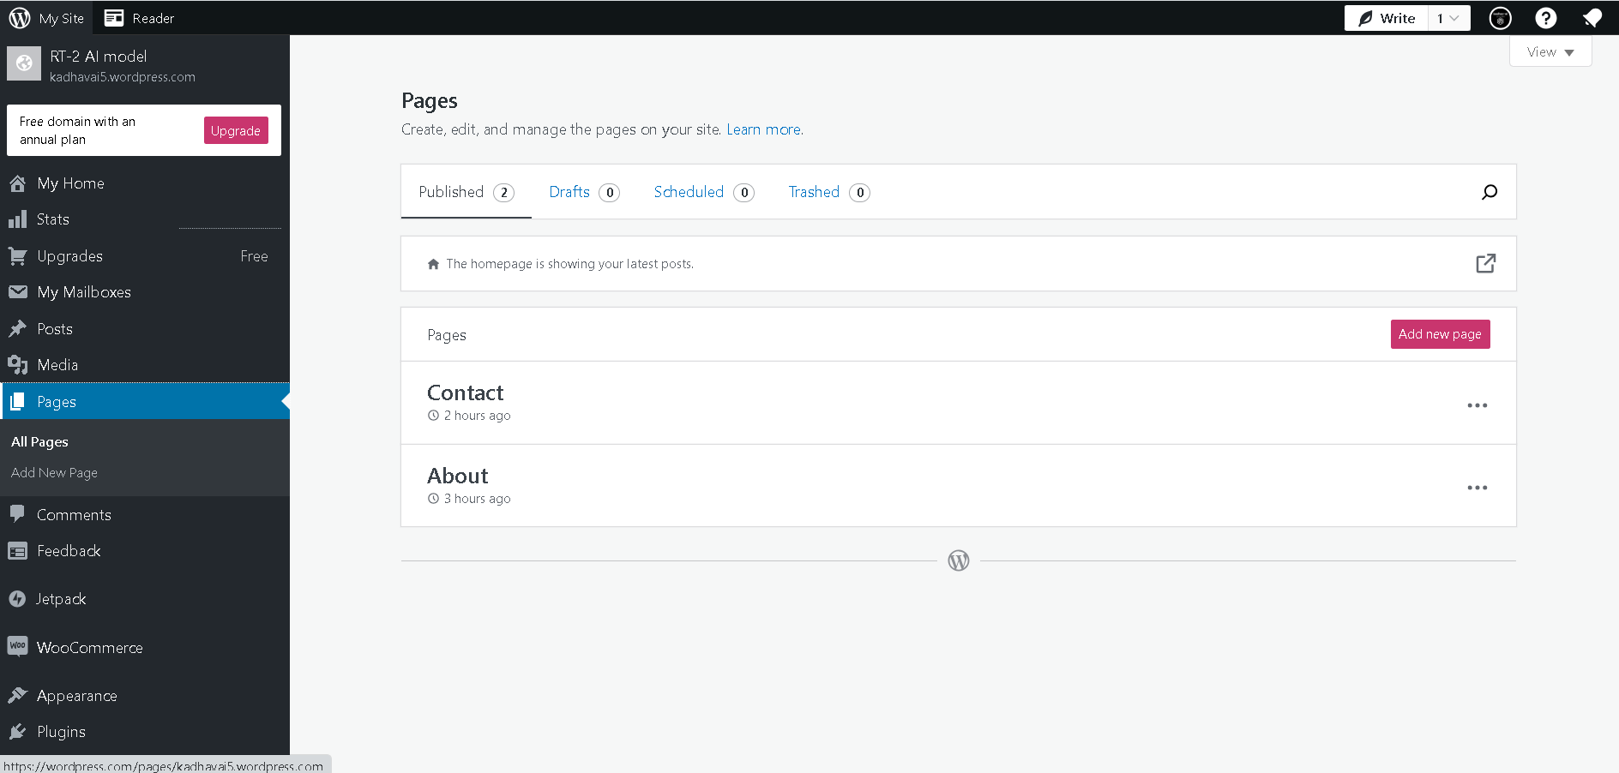

1. Click APPEARANCE and click THEMES and install any theme

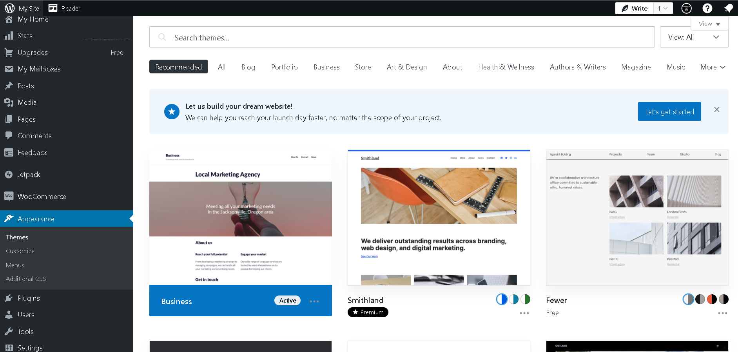

1. Click appearance and click MENUS and add MENU NAME and click ADD MENU and tick the box CONTACT , ABOUT, HOME

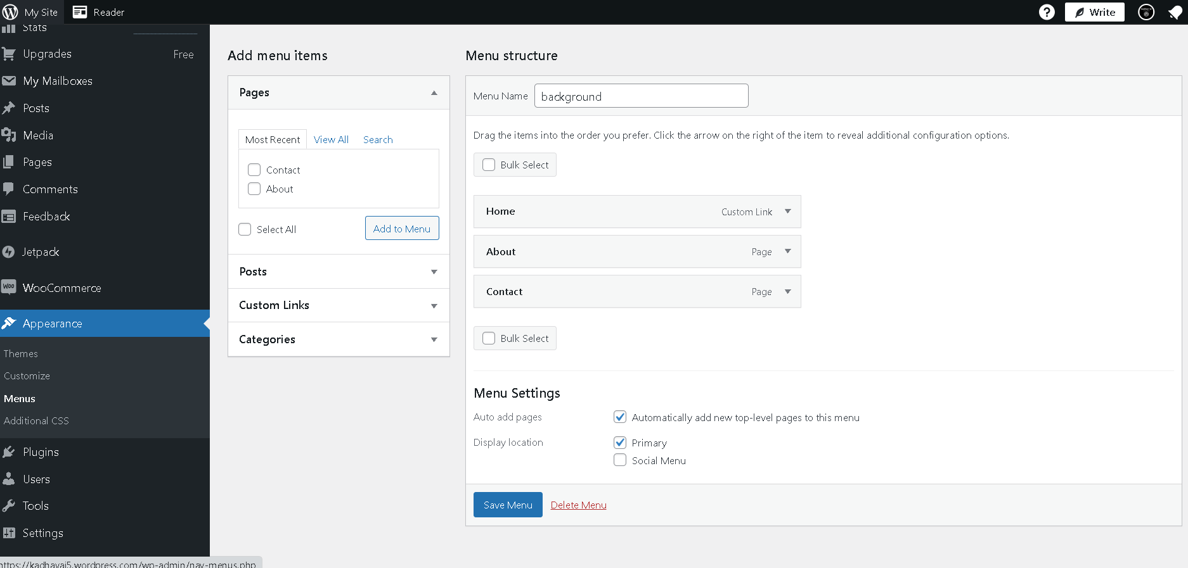

1. Click LAUNCH SITE and copy the URL

<https://kadhavai5.wordpress.com/>

PROJECT VIDEO DRIVE LINK: <https://drive.google.com/file/d/1eUTad0w8k0NW8AB51uGXBPT_JMoeL03J/view?usp=share_link>